Other Websites

Shows in NSW:
Adelong – www.adelongshow.webs.com
Albion Park – www.albionparkshow.org.au
Albury – www.alburyshow.com.au
Alstonville – www.alstonvilleshow.net
Armidale – www.armidaleshow.org.au
Ashford – www.ashfordshow.wix.com/ashfordshow
Bangalow – www.bangalowshow.com.au
Barraba – www.barrabashow.com.au
Bathurst – www.bathurstshow.com.au
Batlow – www.batlowshow.com.au
Bega – www.begashow.asn.au
Bellinger River – www.bellingenshow.com.au
Bemboka – www.bembokashow.org.au
Berrigan – www.berriganshow.com
Berry – www.berryshow.org.au
Bingara – www.bingarashow.com.au
Blacktown – www.blacktownshow.com.au
Bombala – www.bombalashow.org.au
Bonalbo – www.bonalboshow.com.au
Bourke – www.bourkeshow.com
Bowral – www.bowralshow.com.au
Braidwood – www.braidwoodshow.com.au
Bribbaree – www.bribbareeshow.com
Bulahdelah – www.bulahdelahshowsociety.org.au
Bulli – www.thebullishow.com
Bungendore – www.bungendoreshow.com.au
Camden Haven – www.camdenhavenshow.org.au
Camden – www.camdenshow.com
Canberra – www.canberrashow.org.au
Candelo – www.candeloshow.org.au
Castle Hill – www.castlehillshow.com.au
Central Coast – www.centralcoastregionalshow.com.au
Cobargo – www.cobargoshow.org.au
Coffs Harbour – www.coffsharbourshowsociety.com.au
Cooma – www.coomashow.com.au
Coonamble – www.coonambleshow.com
Corowa – www.corowashow.com
Cowra – www.cowrashow.com
Crookwell – www.crookwellshow.com.au
Cumnock – www.cumnockshow.com.au
Dalgety – www.dalgetyshow.com.au
Dapto – www.daptodogs.org.au
Deniliquin – www.deniliquinshow.com
Dorrigo – www.dorrigoshow.org.au
Dubbo – www.dubboshow.org
Dungog – www.dungogshow.com.au
Eurobodalla – www.eurobodallashow.org.au
Finley – www.finleyshowsociety.org
Forbes – www.forbesshow.com
Ganmain – www.ganmainshow.org.au
Gilgandra – www.gilgandrashow.com
Glen Innes – www.gishow.com.au
Gloucester – www.gloucestershow.org.au
Goulburn – www.goulburnshow.com.au
Grafton – www.graftonshow.com.au
Gresford – www.gresfordshow.com.au
Gulgong – www.gulgongshow.org.au
Gundagai – www.gundagaishow.com.au
Gunnedah – www.gunnedahshowsociety.com.au
Gunning – www.gunningshow.com.au
Guyra – www.guyrashow.guyra.net
Hawkesbury – www.hawkesburyshow.com.au
Hillston – www.hillstonshow.org.au
Illabo – www.illabo.org.au
Inverell – www.inverellshowsociety.com.au
Jingellic – www.jingellic.org.au
Kangaroo Valley – www.kangaroovalleyshow.org.au
Kempsey – www.kempseyshow.com
Kiama – www.kiamashow.com.au
Kyogle – www.kyogleshow.com
Leeton – www.leetonshow.weebly.com
Lismore – www.northcoastnational.com.au
Lithgow – www.lithgowshow.org.au
Lockhart – www.lockhartshow.com.au
Luddeham – www.luddenhamshow.com.au
Macksville – www.macksvilleshow.com.au
Maclean – www.macleanshow.org
Maitland – www.Maitlandshowground.com.au
Manilla – www.manillashowsociety.net
Merriwa – www.merriwashow.com.au
Molong – www.molongshow.com
Moree – www.moreeshow.com.au
Morisset – www.morissetshow.org.au
Moss Vale – www.mossvaleshow.com.au
Mudgee – www.mudgeeshow.org.au
Mullumbimby – www.mullumbimbyshow.org.au
Murwillumbah – www.murwillumbahshowground.com
Muswellbrook – www.upperhuntershow.com.au
Narrabri – www.narrabrishow.com.au
Narrandera – www.narranderashowsociety.com.au
Narromine – www.miltonshowsociety.com
Newcastle – www.newcastleshow.com.au
Nimbin – www.nimbinshowsociety.org.au
Nimmitabel – www.nimmitabelshow.com.au
Nowra – www.nowrashow.org.au
Nyngan – www.nynganshow.com
Oberon – www.oberonshow.org.au
Orange – www.orangeshowsociety.org.au
Pambula – www.pambulashow.com
Parkes – www.parkesshow.org.au
Penrith – www.penrithshow.com.au
Picton – www.pictonshow.com.au
Queanbeyan – www.queanbeyanshow.com.au
Quirindi – www.quirindishowsociety.com
Robertson – www.robertsonshow.org.au
Rydal – www.lisp.com.au/~rydalshow
Rylstone – www.rylstonekandosshowsociety.com
Singleton – www.singletonshow.com
Sofala – www.sofalashow.com
St Ives – www.stivesshow.com.au
Stroud – www.stroudshow.com.au
Sydney – www.eastershow.com.au
Tamworth – www.tamworthshow.com.au
Tarago – www.tarago.org.au
Taree – www.tareeshow.org
Temora – www.temorashow.com
Tenterfield – www.tenterfieldshow.org.au
Trundle – www.mytrundle.com.au
Tullamore – www.tullamoreshow.org.au
Tumbarumba – www.tumbarumbashow.com.au
Tumut – www.tumutshowsociety.com.au
Upper Hunter – www.upperhuntershow.com.au
Uralla – www.urallashow.com
Wagga – www.waggashow.com
Walcha – www.walchashow.org.au
Wallamba – www.nabiac.com/show
Wauchope – www.wauchopeshowsociety.com.au
Wee Waa – www.weewaashow.com.au
Wellington – www.wellingtonshow.org.au
Wentworth – www.wentworthshow.org.au
West Wyalong – www.westwyalongshowsociety.com
Wingham – www.winghamshowground.com.au
Woodenbong – www.woodenbong.org
Woodstock – www.woodstockshow.wix.com/woodstockshow
Yass – www.yassshow.org.au
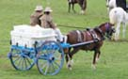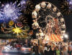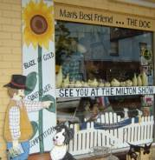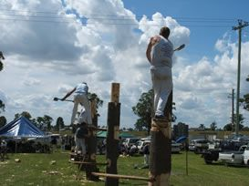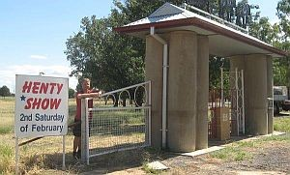

State Bodies:
QLD – Queensland Chamber of Agricultural Societies Inc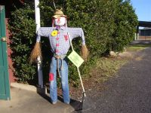
NSW – Agricultural Shows of NSW
VIC – Victorian Agricultural Shows Ltd
TAS – Agricultural Show Council of Tasmania Inc
SA – Agricultural Societies Council of SA Inc
NT – Royal Agricultural Society of the Northern Territory Inc
WA – Royal Agricultural Society of Western Australia Inc
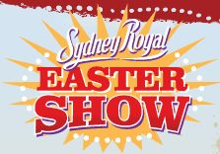

Royal Shows: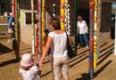
Royal Queensland Show – the ‘Ekka’ – www.ekka.com.au
+ Royal National Agricultural & Industrial Association of Queensland – www.rna.org.au
Royal Sydney Easter Show – www.eastershow.com.au
+ Royal Agricultural Society of NSW – www.rasnsw.com.au
Royal Canberra Show – www.canberrashow.org.au
+ Royal National Capital Agricultural Society – www.canberrashow.org.au
Royal Melbourne Show – www.royalshow.com.au
+ Royal Agricultural Society of Victoria – www.rasv.com.au
Royal Hobart Show – www.hobartshowground.com.au/show/
+ Royal Agricultural Society of Tasmania – www.hobartshowground.com.au
Royal Adelaide Show – www.theshow.com.au
+ Royal Agricultural & Horticultural Society of SA – www.adelaideshowground.com.au
Royal Darwin Show – www.darwinshow.com.au
+ Royal Agricultural Society of the Northern Territory – www.darwinshow.com.au
Royal Perth Show – www.perthroyalshow.com.au
+ Royal Agricultural Society of WA – www.raswa.org.au

Other Websites: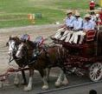
Australian Heavy Horses – www.aussieheavyhorses.com
Country Shows – www.countryshows.com.au
Emma’s Show Horses & Accessories – www.emmaswebsite.com.au
Equestrian Federation of Australia – www.equestrian.org.au
Have Horse … Will Travel – www.havehorsewilltravel.com.au
Showmens Guild – www.showmensguild.com.au

Local people make local shows

